(Approx. 834 words)

9 Mac System Preferences You Haven’t Tweaked Yet
By Justin Pot, MakeUseOf.com, May 26, 2015
http://bit.ly/1I0YiDN

Make your Mac your own, without third party software. Whether you’re new to OS X or a longtime user, there’s probably something in System Preferences you haven’t found yet. Here are nine things you might have missed.

We’ve been digging into the Mac preferences for years <http://bit.ly/1KFkVBq> but to this day there are things we haven’t pointed out yet.

To get started, click the Apple icon at top-left, then click System Preferences.

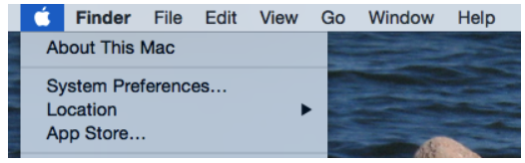

That’s right: you don’t need to keep the System Preferences icon on your dock anymore (you can even launch it via Spotlight). And now that we’re in, let’s get to the real tips.

Enable Apps From Outside the App Store

By default, OS X programs without a developer’s license won’t run – instead, you’ll be treated to a message like this:

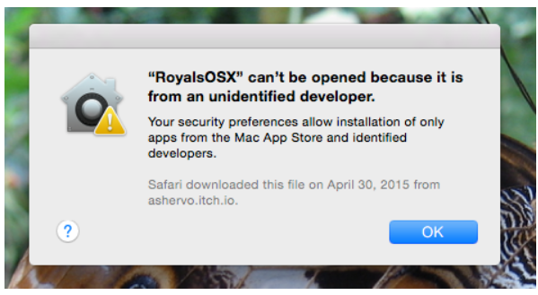

This is called Gatekeeper, and it protects your Mac, but it can also be pretty annoying if there’s a piece of software you want to run. It’s especially annoying because many of the best Mac apps won’t run.

If you’d like to never see this message again, head to your System Preferences, then click Security & Privacy. You’ll find the appropriate setting in the General tab:

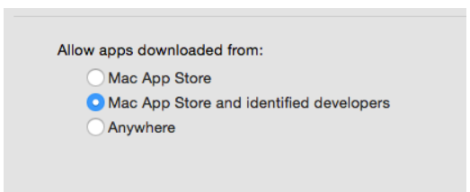

Set Up Autoreplace for Easy Text Expansion

If you head to the Keyboard section of System Preferences, then click the Text tab, you can create text expansions for yourself.

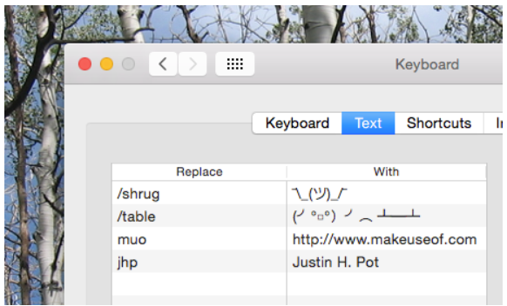

If there are relatively long phrases you find yourself typing often, create a one-word shortcut for it – when you type that phrase in any program, OS X will transform it for you. It’s also a great way to quickly use ASCII art – you can see, I’ve added a “/shrug” command for myself.

Schedule Wake-Up and Sleep Times

If you use your computer on a set schedule, and would prefer you didn’t have to wake it up yourself, head to the Energy Saver section of your Mac’s settings. Click Schedule at the bottom-right corner and you can tell your Mac when to wake up and go back to sleep.
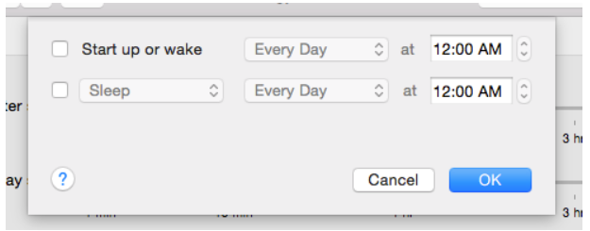

If you’ve scheduled your Time Machine backups you could use this to ensure your Mac is on when you want your backup to run, but there are a lot of other potential uses.

Set Up Hot Corners To Quickly Do Anything

Hot Corners is something many Mac users swear by, but not everyone knows about. And it’s kind of hidden: head to “Mission Control”, then click the “Hot Corners” button.

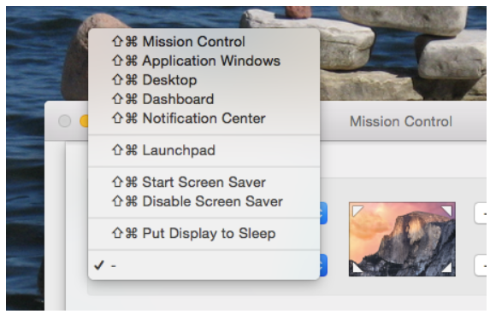

You can now trigger a number of things by moving your mouse to a particular corner. You might hate it, but if not you’ll wonder how you ever used your Mac without it.

Add a Lock Message In Case You Lose Your Mac

In System Preferences, head to Security & Privacy and you’ll find the Set Lock Message button.

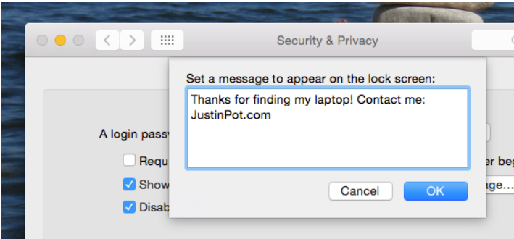

Personally I like to leave contact information, in case I lose my laptop and someone wants to return it. But you could just leave a nasty message for your sister, who keeps trying to use your laptop when you’re out of the room and totally needs to stop doing that.

Turn Off Notifications During Your Work Day

Notifications can be the enemy of focus, which is why you should try to avoid them during your work day. Head to Notifications, then look under Do Not Disturb.

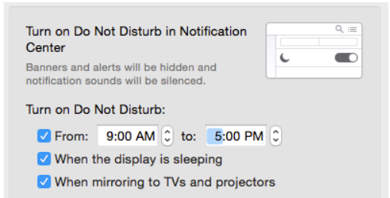

While you’re at it, I recommend making sure notifications won’t show up on mirrored devices – you don’t want a message from your buddy showing up during a presentation, right?

Explore What Your Trackpad Can Do

This isn’t really little-known, but if your Mac has a trackpad you should really check out the Trackpad settings. It’s just as much a tutorial as it is a preferences panel – you’ll learn some useful gestures, and you’ll be able to tweak others to better suit your needs.

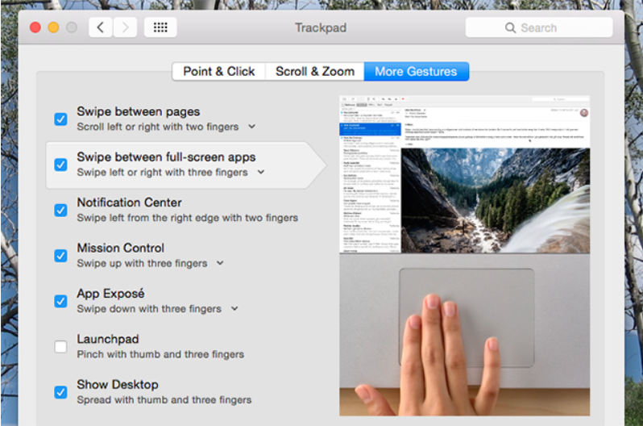

If this isn’t enough control for you, I recommend powering up your trackpad with BetterTouchTool.

Mac Custom Keyboard Shortcuts

You can create a custom keyboard shortcut for almost anything, thanks to the “Shortcuts” section of the “Keyboard” preferences pane.

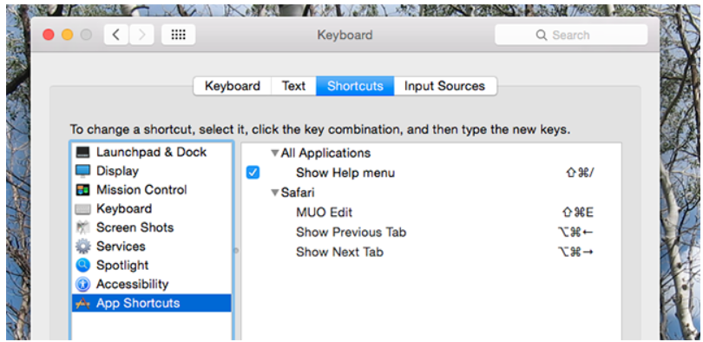

Personally I use this to create key keyboard shortcuts in Safari, but there’s no limit to what you can do.

Handy Shortcut: Right-Click Preferences Icon for a List

Finally, here’s a quick way to jump to any System Preferences panel quickly. On the dock, right-click the Preferences icon – you’ll see a list.

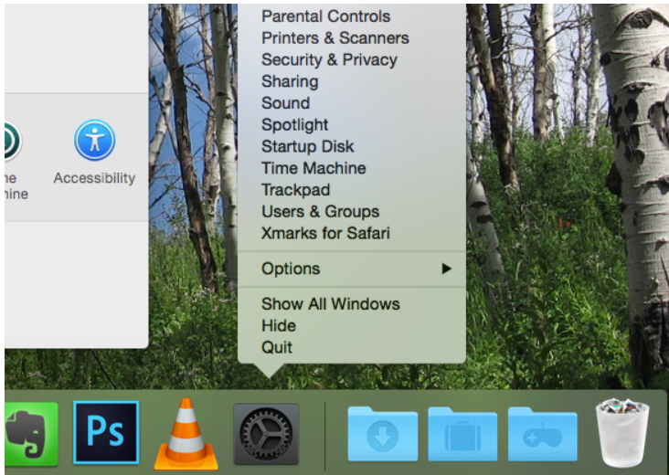

Maybe it’s worth keeping that icon on your dock after all, huh? Lots of Mac apps have useful shortcuts here, so right-click more icons while you’re at it.
There’s More Great OS X Tweaks Out There!

Want to keep tweaking? You should explore System Preferences yourself and report back with the best things you find.

Of course, to really dig deep into customizing your Mac you’ll need to become comfortable with the Terminal. Once you do, you can customize OS X in ways the GUI cannot or even install software using four-word commands.

